Insulation Panel Research

# Insulation Panel Test

## Procon Masterpanel

Figure 1: Start - Heater on

Figure 2: 5:45 - Heater on

Figure 3: 100c – Heater Off at 12 min mark

Figure 4: 15min - Heater off

Figure 5: 21:45 - Heater Off

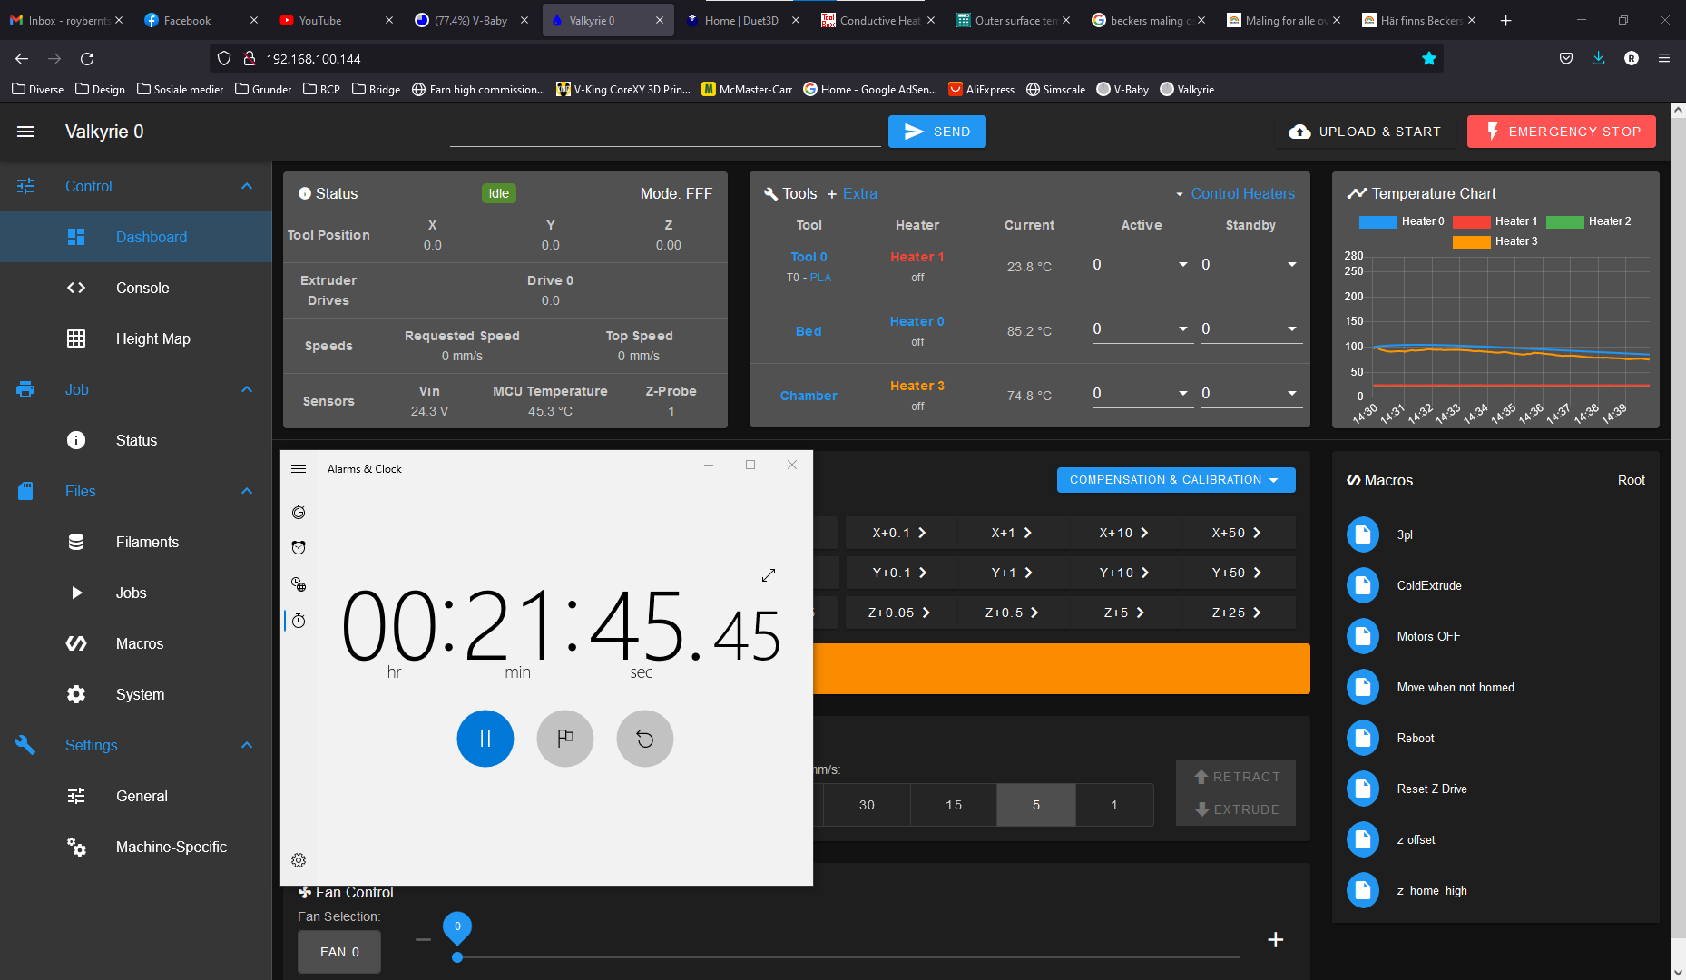

Figure 6: 30 min - Heater Off

Figure 7: 1h - End of test

